**Leader Overview**

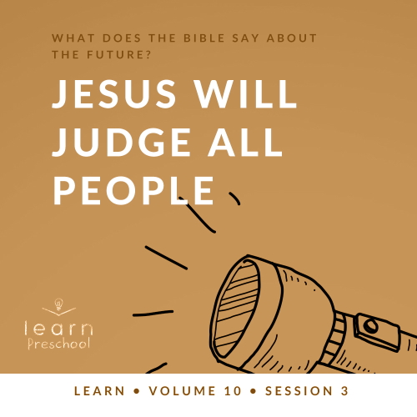

**Volume Overview**

**What does the Bible say about the future?**

*It’s easy to see that our society is obsessed with the future. But what does the Bible say about the future? While it was written thousands of years ago and much of its contents has already taken place, we do get a glimpse of the future in the Bible. We know there is life beyond this life. We know the brokenness and pain in this world will not last forever. We know God will make all things new, and He will right every wrong. For Christians, the future is something we can look forward to.*

**Session Overview**

**Jesus Will Judge All People**

*In this* **Learn** *session, preschoolers will discover we all have the freedom to make choices in this life, but those choices have consequences for what happens to us after death. This sobering parable of a rich man and Lazarus reminds us that all people will be judged for the way they choose to live their life on earth.*

**Bible Lesson**

Parable of the Rich Man and Lazarus

[Luke 16:19–31](https://ref.ly/logosref/Bible.Lk16.19-31)

**Faith Fact**

Jesus gives me a choice.

**Faith Verse**

[1 Corinthians 2:9](https://ref.ly/logosref/Bible.1Co2.9) (NLT)

“No eye has seen, no ear has heard, and no mind has imagined what God has prepared for those who love him.”

**Preparing for the Session**

**Leader Preparation Time: 20–25 Minutes**

|  |
| --- |
| ***You Will Need***  ***Preservice Activities***  *• Two snack options*  *• Toys*  ***Large Group***  *• Bible*  *• Worship songs (Song suggestions: “Praise Goes On” by Elevation Worship Lyric Video; “Ask Seek Knock” by Hillsong Kids; “We Came to Meet with You” by Hillsong Kids)*  *• For groups not using a phone or tablet only, add:*  *• Projector or TV*  *• Laptop*  *•* ***Faith Fact Sound*** *video (bell ringing)*  *•* ***Faith Fact Slide***  *•* ***Faith Verse Slide***  *•* ***Bible Lesson Video A***  *•* ***Bible Lesson Video B***  ***Small Group***  *• Six paper lunch bags*  *• Four small items (e.g., cotton balls, stickers, torn up paper, used coffee cup)*  *• Candy, one piece per kid*  *• Marker*  *• Extra candy for leader to give to everyone*  *•* ***Small Group Activity Page****, one per kid*  *• Crayons, highlighters, markers, or colored pencils*  *• Pitcher of water*  *• Clear glass jar or drinking glass*  *• Bleach*  *• Liquid food coloring (green, red, yellow, and blue)*  *• Spoon with long handle*  *To access session content and videos from a computer, visit:* [***BibleEngagementProject.com/downloads***](https://bibleengagementproject.com/downloads) |
| ***Getting Ready***  ***Preservice Activities***  *• Set out toys and snacks.*  ***Large Group***  *• Download videos and slides if needed.*  *• Select worship song(s) and have them ready to play.*  ***Small Group***  *• Using the marker, number the bags 1 to 6.*  *• Place candy in one bag.*  *• Place the other four items in four of the remaining bags.*  *• Leave one bag empty but blow air into it to make it look like something is in it.*  *• Place the bags in six different locations around the room.*  *• Print copies of the* ***Small Group Activity Page****, one per kid.*  *• Test object lesson to ensure the proper amount of bleach.*  *• Choose a location where the kids can easily see the lesson without being too close to the bleach.*  *First time leading* Learn *for Preschool? Check out the* [***Facilitator Guide***](https://0b769b0ed3569ef9d18b-f88d8272f61086866d50d048b43ef630.ssl.cf2.rackcdn.com/sites/biblengagementproject/Listen_Facilitator_Guide.pdf)*.* |

**Preservice Activities**

*See what’s needed at the beginning of the session.*

**Bible Story Warm-Up**

We make a lot of choices throughout the day. We get to choose what color socks we put on or which shirt we wear. Maybe we get to pick what kind of shoes we put on and what we will eat for breakfast. All day long we make choices. Now some of these choices are bigger than others. If we aren’t careful, we might make a wrong choice. Have you ever made a wrong choice? *(Group response)*

Some choices are easier to make though. I’m going to tell you some of the choices I have to make tomorrow. I want you to tell me if I should choose it or not. Ready? *(Group response)*

• *Read list of options to kids and allow them to tell you if it’s a good choice or a bad choice. Ask why or why not to help kids express the best choices to make.*

• *Add some of your own personal choices.*

1. Staying in bed even though the alarm went off

2. Brushing my teeth

3. Putting on my socks and shoes

4. Eating a candy bar for breakfast

5. Giving a hug to my family when I leave the house

6. Giving my pet a whole bunch of food so he can eat as much as he wants all day

7.  *(If applicable)* Leaving my kids home alone to take care of themselves

8. Watching TV and videos all evening

9. Doing the dishes

10. Staying up after my bedtime

Thanks for helping me with my choices for tomorrow!

Do you ever have a hard time making choices?

Who can help you know if something is a good choice or a bad choice?

What should you do if you make a bad choice?

We can talk to someone else like our parents when we make a bad choice, can’t we? *(Group response)* Can we can talk to God? *(Group response)* We’ll find out more about the choices God wants us to make as we look into our Bible lesson today.

**Snack**

**Two Snacks Options**

Today, we’re learning about making choices. You have a choice to decide which snack you want. You can choose *(insert snack option)* or (*insert snack option)*.

• *Let kids select their snacks.*

• *As kids are eating the snacks, ask the following:*

Is it fun to get to choose your own snack?

Was it hard for you to choose only one? Why?

How does it make you feel when you don’t get to choose?

**Free Play**

*Any extra time can be spent playing with toys.*

**Transition**

*A few minutes before service begins have kids make their way to the large group area and sit in their designated areas.*

**Large Group**

**25 Minutes**

*See what’s needed at the beginning of the session.*

**Introduction**

Hey, everybody! I’m so excited to be here today. I love getting to spend time with you and learn about God’s Word. *(Hold up Bible.)* If you’re excited to be here, say, “You know it!” *(Group response)* Awesome! Sounds like everyone is just as excited as I am.

Today, we’ll learn about an incredible choice that Jesus has given us. Jesus doesn’t force us to love Him or to follow Him. Instead, He gives each of us the choice. When we choose to love Jesus, it makes Him glad. When we choose to disobey what He wants for us, we sin, and that separates us from Him. It might seem hard to make good choices sometimes, but I’m really glad that Jesus gave us the choice. When we choose to love Jesus or not, we show Him, and ourself, that it’s what we really want.

**Faith Fact**

Did you know that the choices we make cause other things to happen? *(Group response*) If we make good choices and follow Jesus and the plans He has for us, we will be blessed. If we choose to make bad choices, there will be consequences. Now, this doesn’t need to be scary because the more we read and learn about God’s Word, the easier it will be to make good choices. It’s really awesome that Jesus gives us the choice to follow Him. In fact, that’s exactly what our Faith Fact says: **Jesus gives me a choice.**

• *Show the* ***Faith Fact Slide.***



Before we say the Faith Fact, I’m going to give you a choice. You can choose if we say the Faith Fact really fast or really slow.

• *Demonstrate speaking quickly or slowly as you say the choices.*

Raise your hand if you want to say it really fast. *(Group response)* Raise your hand if you want to say it really slow. *(Group response.)*

It looks like we’re going to say it *(kids’ choice here).* Ready? 1, 2, 3. **Jesus gives me a choice.** Great job! Now, let’s say it one more time the other way. Ready? **Jesus gives me a choice.**

**Bible Time**

A great choice we can make is to learn more about God’s Word. It helps us know what the right choices are. We have someone special to help us with that today. Why don’t we check in with our friend Lizzy and see what she’s up to.

• *Play* ***Bible Lesson Video A****.*

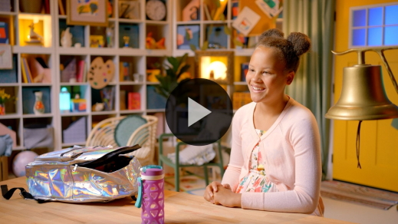

Wow! This Faith Verse is no match for you. You’re doing a great job learning it. The last part of our verse says that God has prepared something incredible for those who love Him. This lets us know that it’s our choice to love God. When we choose to love God, we receive the blessings He has for us. It’s important for everyone to know that. And it’s why we’re learning this Bible verse together.

**Worship**

Another choice we can make is to live a life of worship. When we do what our parents tell us to or help a friend, that can be worship if we do it because God wants us to. Worship also can be singing, but it isn’t just about the songs we sing. It’s about how we live our life for Jesus.

**Praise**

Are you glad Jesus is with us? Give your neighbor a high five. *(Group response)*

Do you want to make the right choices? Clap your hands twice. *(Group response)*

Who wants to tell Jesus thank You for choosing to love us? Say, “Thank You, Jesus.” *(Group response)*

**Sing**

With our hands lifted high, let’s take this time to show God how much we love Him as we sing.

• *Lead the kids in singing one or two songs. See song suggestions at the beginning of the session.*

**Prayer**

Now, that was beautiful. When we choose to worship Jesus and obey Him, I know it makes God happy. We just spent these last few minutes singing and telling God how much we love Him. Let’s continue to do that as we pray together.

|  |
| --- |
| Dear God, thank You for loving us. Thank You for always being with us. We’re so glad that You have given us the choice to love and follow You. Help us to always make the right choices about the things You want us to do. Amen. |

**Bible Time cont’d**

I loved getting to worship with you today. Let’s take our learning to the next level and check back in with Lizzy. I think she and Grandpa may have a Bible story for us.

• *Play* ***Bible Lesson Video B.***

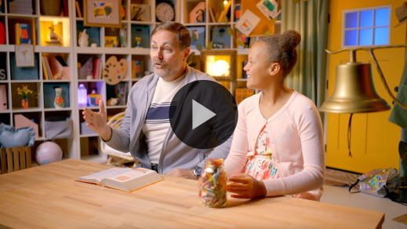

That was an amazing Bible story about how important it is to make the right choice and follow Jesus. What we choose in life determines what happens after we die. The poor man named Lazarus and the rich man both made choices. One man’s choices made God sad. Who was that? *(Allow responses.)* That’s right, the rich man. He chose other things instead of God. Whose choices made God happy? *(Allow responses.)* Yes, it was Lazarus. Although he was poor and had a hard life, Lazarus was able to receive good things from God when he was done living on earth.

It’s important that we choose Jesus. Then, at the end of our life, we’ll know that we lived for Him. The cool thing about this story is it reminds us that grown-ups have to make good choices, too. It’s not just something that you have to do when you’re young. Making the right choice is a lifelong decision. We don’t want to choose the wrong thing and miss out on the great things God has for us.

**Response Time**

• *Play a worship song quietly.*

Sometimes it can be hard to make the right choices. That’s why right now we’re going to choose to pause and respond to what we’ve learned today. Responding to God means we think about what we learned and ask God how it can help us. As we pray, I want you to put your hands in front of you *(place hands in front with palms up).* Let’s ask God to help us make the right choices. Let’s pray.

• *Optional: Have the kids repeat phrases of the prayer after you.*

|  |
| --- |
| Dear God, I’m so glad I get to choose to follow You. I want to live my whole life to honor You. I know making the right choices won’t always be easy, so I need Your help. I will do my very best and look to You for help when I need it. I love You. Amen. |

**Faith Verse**

Did you know that learning Bible verses can help us make the right choices? The Holy Spirit can bring verses to our mind when we’re making choices about what to do. Let’s say our Faith Verse and do the actions together.

[1 Corinthians 2:9](https://ref.ly/logosref/Bible.1Co2.9) (NLT)

“No eye has seen, no ear has heard, and no mind has imagined what God has prepared for those who love him.”

• *Show the* ***Faith Verse Slide***.

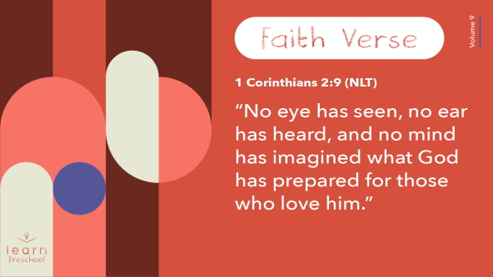

That was so great! You’re doing such a good job with our Faith Verse.

**Closing**

Who had fun today? *(Group response)* Who learned something new today? *(Group response)* We’ve worshipped God by singing and praying. We’ve learned a Faith Verse from the Bible. We’ve learned that Jesus doesn’t make us love Him and follow Him. Instead, He allows us to choose that for ourself. That’s pretty awesome!

• *Play the* ***Faith Fact Sound*** *video (bell ringing).*

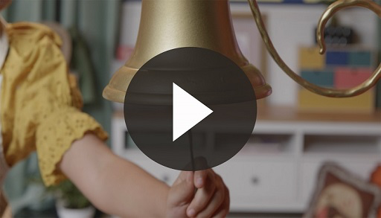

That sound means it’s time to say our Faith Fact one more time. **Jesus gives me a choice.**

• *Show the* ***Faith Fact Slide.***



Let’s shout it together. Ready? **Jesus gives me a choice.** Now, I want you to look at one of your neighbors and point at yourself as you say the Faith Fact to them. Ready? **Jesus gives me a choice.** Just like in our Bible story, Jesus gives us a choice to follow Him. It’s the most important choice you and I can make.

**Dismissal to Small Groups**

So good! Let’s keep the learning and fun going as we head to our circles together.

• *Dismiss the kids by groups*.

|  |
| --- |
| ***Leader Tip:*** *This can be done by assigning color teams or by age groups. Note that some young preschoolers may not know their age. Using a colored sticker, jersey, or wristband will help separate the kids and help identify their small groups.* |

**Small Group**

**25 Minutes**

*See supplies and prep instructions at beginning of session or in each activity below.*

|  |
| --- |
| ***Leader Tip:*** *Small groups can alternate to each circle, or all groups can do each activity at the same time. If you choose to alternate, you will need at least one leader per circle.* |

**Circle 1**

**Group Connection**

**Pass It or Keep It**

|  |
| --- |
| ***You Will Need***  *• Six paper lunch bags*  *• Four small items (e.g., cotton balls, stickers, torn up paper, used coffee cup)*  *• Candy, one piece per kid*  *• Marker*  *• Extra candy for leader to give to everyone*  ***Getting Ready***  *• Using the marker, number the bags 1 to 6.*  *• Place candy in one bag.*  *• Place the other four items in four of the remaining bags.*  *• Leave one bag empty but blow air into it to make it look like something is in it.*  *• Place the bags in six different locations around the room.* |

Today, we’re learning about the importance of the choices we make. Some choices in life are really big like choosing to follow Jesus. Others are smaller like deciding which sock to put on first when we get dressed. We’re constantly making choices. Right now, you’ll have a chance to make a choice.

I have six paper bags filled with different things around the room. One at a time, I’m going to hold up the bags. After you’ve seen all the bags, I’ll ask you which bag you want to choose, and you’ll go and stand by that bag. You may not be able to tell if there’s anything inside of each bag. There might be something good like a treat. It could be filled with my lunch from yesterday. Maybe there’s nothing in it at all. When everyone has made their choice, we’ll open all the bags and see what’s inside.

• *Hold up each of the bags and shake them or move them around to help the kids determine if there’s something inside.*

• *Have kids stand by the bag they chose.*

Now, let’s open the bags and see what each one of you picked.

• *If the bag has something to share, give them their prize.*

What do you think of the choice you made? *(Allow responses.)* Some of you chose good things like a treat. Others chose something that wasn’t quite as good. I hope you learned that it’s important to take your time when making choices. Every time I held up a bag, I shook it around to help you hear what was inside. Even then, it may have been hard to be sure you were choosing something good.

Thankfully, when Jesus gives us a choice, we can be sure what He wants for us is always good. Let’s say our Faith Fact together one more time as a reminder. **Jesus gives me a choice.**

You did such a great job celebrating with other people as we opened up each of the bags. I think each of you should get a prize.

• *Give any kid candy who didn’t choose the bag with the candy.*

• *During the activity, interrupt and practice the Faith Fact:* **Jesus gives me a choice.**

• *Play the* ***Faith Fact Sound*** *video. Review the Faith Fact even if you can’t play the sound.*



**Circle 2**

**Activity Page Time**

**Count and Color**

|  |
| --- |
| ***You Will Need***  *•* ***Small Group Activity Page****, one per kid*  *• Crayons, highlighters, markers, or colored pencils*  ***Getting Ready***  *• Print copies of the* ***Small Group Activity Page****, one per kid.* |

Who can tell me something you’ve learned today? *(Allow responses.)* Yes! Those are all things we’ve learned. It’s amazing all the things we can learn when we focus on God and His Word. Memorizing the Faith Verse is one of those important things we can choose to do. Why don’t we say it together right now?

[1 Corinthians 2:9](https://ref.ly/logosref/Bible.1Co2.9) (NLT)

“No eye has seen, no ear has heard, and no mind has imagined what God has prepared for those who love him.”

• *Lead the kids in saying Faith Verse. Be sure to do the actions as well.*

Great job! Today, we have an awesome Activity Page about our Faith Verse. Our Faith Verse talks about our eyes and ears and love. Beside each shape is a number. Trace the number. Then, circle the correct number of the pictures in that row.

• *Hand out a copy of the* ***Small Group Activity Page*** *and crayons to each kid.*

• *Allow time for kids to complete the activity. Help as needed.*

Let’s say our Faith Verse together one more time before we move on.

[1 Corinthians 2:9](https://ref.ly/logosref/Bible.1Co2.9) (NLT)

“No eye has seen, no ear has heard, and no mind has imagined what God has prepared for those who love him.”

Thanks for choosing to say the verse with me. That was great!

**Circle 3**

**Feet-to-Floor Game Time**

**I Choose You**

|  |
| --- |
| *No prep needed for this activity.* |

Who wants to play a game? *(Group response)* We’ll sit in a circle, and one of you will be “It.” When you’re “It,” you’ll go around the outside of the circle and lightly tap each friend’s shoulder or head as you say each word of the Faith Fact. We’re adding a little bit of a twist to it. I want you to say, “Jesus gives me a choice, and I choose you.” When you say, “you,” the person you touch will stand up, chase you around the circle, and try to tag you before you make it back around to their spot. If they don’t tag you, they get to be “It.” Who’s ready to play? *(Group response)*

• *Make sure the kids don’t tap their friends too hard.*

• *Play until everyone has had a chance to be “It” if you have time.*

• *Options to add: Freeze: Everyone stops and yells out the Faith Fact together. Reverse: Runners stop and switch directions so that the person who was being chased is now “It.”*

**Circle 4**

**Hands-On Learning**

**Color My Life**

|  |
| --- |
| ***You Will Need***  *• Pitcher of water*  *• Clear glass jar or drinking glass*  *• Bleach*  *• Liquid food coloring (green, red, yellow, and blue)*  *• Spoon with long handle*  ***Getting Ready***  *• Test object lesson to ensure the proper amount of bleach.*  *• Choose a location where the kids can easily see the lesson without being too close to the bleach.* |

Today, we are learning about making choices. God has given us an amazing choice to follow Jesus. We get to choose to love Him and live with Him forever. Isn’t that wonderful? *(Group response)* We get to choose not only to love Him but also how we want to live. God doesn’t force us to be faithful and follow Him. He wants us to choose to do that on our own.

Before we follow God, our life is empty like this. *(Hold up empty jar.)* When we choose to follow God, He fills us up. *(Pour water in the jar.)* Can you see anything in there? *(Group response)* We don’t always feel God in us, but He makes us clean and pure. Then, we decide what kind of life we want to live. Like the people in our Bible story, God has good things for us when we decide to live how He wants.

Should we choose to love God and be filled with things that honor God? *(Group response)* Yes, we want to honor God. Let’s choose green to represent following God. *(Add green coloring to the water.)* Then, let’s add some love *(red food coloring)* and a little bit of joy *(yellow food coloring).*

• *Don’t stir the water yet.*

What happens if we make a bad choices and sin enters our life? *(Add blue food coloring.)* It begins to mix in with the good things and changes the color of our life. *(Stir the water.)* We’re no longer growing or showing love and joy as much as we used to. Thankfully, Jesus offers His love and forgiveness to us when we ask Him.

• *Begin pouring the bleach into the water. The bleach should immediately begin to react with the color in the water, changing it to clear water again.*

Jesus can make us like new because He died for us to take our sins away. Isn’t it amazing that we can choose to live our life to honor Him? God wants us to stand before Him one day with a life that makes Him proud so that we can spend all eternity with Him. That’s what Jesus wants us to choose.

**Dismissal**

• *Play the* ***Faith Fact Sound*** *video (bell ringing).*



• *Show the* ***Faith Fact Slide.***



Let’s say the Faith Fact together one last time before we go. **Jesus gives me a choice**. I had a great time choosing to learn more about following God with you. See you next time!

• *Send home the* ***Small Group Activity Page*** *with each kid.*

• *Remind parents that there are* ***Family Devotions*** *available on the app to do with their kid.*

• *Tell everyone the date and time for the next session.*